Nottingham Trent University
School of Science and Technology

Adaptive Gamified Productivity System

by

Waing Waing
in
2026

Project report in part fulfilment
of the requirements for the degree of
Bachelor of Science with Honours
In
Computer Science

I hereby declare that I am the sole author of this report. I authorize the Nottingham Trent University to lend this report to other institutions or individuals for the purpose of scholarly research.
I also authorize the Nottingham Trent University to reproduce this report by photocopying or by other means, in total or in part, at the request of other institutions or individuals for the purpose of scholarly research.

Signature
Waing Waing

Abstract
Many students and professionals use productivity apps to manage tasks and organise their time. However, many failed to sustain long-term user engagement due to repetitive interaction patterns and limited motivational feedback. As a result, users often abandon such systems when task completion becomes routine and unrewarding.
To address this issue, this project develops an Adaptive Gamified Productivity System designed to enhance user motivation and engagement through the integration of gamification techniques. The system incorporates task management, Pomodoro-based focus sessions and a gacha-style randomised reward mechanism to encourage continued use. The prototype was developed using Unity for PC-based implementation.
User testing was conducted with 7 participants to evaluate the effectiveness of the system, with initial results indicating improvements in user focus and engagement. These findings indicates that the integration of randomised reward systems can positively influence productivity behaviours.
While the implementation was successful, there were still several limitations including the need for improved user interface design and increased customisation options. Future improvements will focus on refining these aspects to enhance usability and overall user experience.

Acknowledgements
I would like to express my sincere gratitude to my supervisor, Dr Simon Schofield for their guidance, support and feedback throughout the duration of this project.
I also would like to thank the participants who took part in the user evaluation for their time and feedback.

Table of Contents
Abstract ii
Acknowledgements iii
Table of Contents iv
List of Figures viii
List of Tables ix
CHAPTER 1 1
Introduction 1
1.1 Introduction 1
1.2 Background 1
1.3 Problem Statement 2
1.4 Proposed Approach 2
1.5 Aim and Objectives 3
1.6 Scope of the project 3
1.7 Structure of the report 4
CHAPTER 2 5
CONTEXT (Literature review) 5
2.1 Introduction 5
2.2 Productivity Systems 5
2.3 Gamification 6
2.4 Gacha/Random Reward Systems 7
2.5 Motivation Psychology 9
2.6 Existing Solutions Analysis 11
2.7 Summary of Gaps 12
CHAPTER 3 14
New Ideas 14
3.1 Introduction 14
3.2 System Overview 14
3.3 Requirements 15
3.4 System Design 16
3.5 User Interaction 16
3.6 User Interface Design 18
3.7 Unique Selling Points 19
3.8 Technical Specifications 20
3.9 Risks and Challenges 21
3.10 Conclusion 22
CHAPTER 4 24
IMPLEMENTATION or INVESTIGATION 24
4.1 Introduction 24
4.2 Development Environment 24
4.3 System Architecture 25
4.4 Feature Implementation 25
4.5 User Interface Implementation 27
4.6 Development Process 27
4.7 Project Planning 28
4.8 Challenges and solutions 28
4.9 Summary 31
CHAPTER 5 32
RESULTS / DISCUSSION 32
5.1 Introduction 32
5.2 Functional Testing 32
5.3 Non-Functional Testing 36
5.4 Quantitative Results 44
5.5 Qualitative Feedback 45
5.6 Successes and Limitations 46
5.7 Discussion 47
5.8 Summary 48
CHAPTER 6 50
CONCLUSIONS / FUTURE WORK 50
6.1 Conclusions 50
6.2 Review of Objectives 51
6.3 Limitations 51
6.4 Future work 52
6.5 Legal, Social, Ethical and Professional Issues (LSEPI) 53
6.6 Synoptic Reflections 54
ReferenceS 56
Appendix A 58

List of Figures
Figure 1: Flow chart of Adaptive Gamified Productivity System 17
Figure 2: Figma wireframe for Dashboard and Focus Mode 18
Figure 3: Figma wireframe for Gacha Interface and Task Manager 19
Figure 4: Figma wireframe for Team selection 19
Figure 5: Gantt Chart 28
Figure 6: Gacha Screen Before Changes 29
Figure 7: Gacha Screen After Changes 30
Figure 8: Focus Timer Screen Before Changes 30
Figure 9: Focus Timer Screen After Changes 30
Figure 10: Usability rating 38
Figure 11: Interface clarity rating 38
Figure 12: Engagement rating 39
Figure 13: Motivation rating 40
Figure 14: Enjoyability rating of random rewards 40
Figure 15: Continue usage of the system rating 41
Figure 16: Focus rating 42
Figure 17: Improvement rating 42
Figure 18: Productivity over other tools rating 43
Figure 19: Reward fairness and addictive rating 44
Figure 20: Improvement Feedbacks 46

List of Tables
Table 1: Black box testing 35
Table 2: Black box testing 45

Introduction

Introduction
Productivity applications have become increasingly common tools for task management, time organisation and improving personal efficiency. Despite these features, many productivity systems struggle to maintain long-term user engagement. This project addresses that problem by developing an Adaptive Gamified Productivity System, combining task management and focus techniques with game-based reward mechanisms. The system is designed to enhance user motivation by transforming routine productivity tasks into engaging and rewarding experiences.

Background
Traditional productivity tools typically rely on task lists, reminders and scheduling features. While these useful for short-term organization, research implies that user engagement tends to decline over time as interactions become repetitive and feedback feels predictable.
In recent years, gamification has appeared as a strategy to improve user engagement by incorporating elements of game design such as rewards and progression systems into non-game contexts. These elements can make otherwise routine activities more interactive and enjoyable. The Pomodoro Technique is a time management technique that structures work time into fixed intervals separated with short breaks. From the research, it can be seen that this approach can improve focus and reduce mental fatigue, the length of the time varies for individuals.
Another approach is the gacha-style reward system, borrowed from mobile gaming. These systems introduce randomised rewards, creating anticipation that may sustain engagement beyond what fixed feedback systems can achieve. However, their application raises ethical considerations around compulsive use, which this project has to address through careful design decisions.

Problem Statement
The main problem motivating this project is that most productivity applications fail to maintain consistent user engagement due to a lack of dynamic motivational systems that encourage continued use. Task completion often becomes repetitive, leading to reduced user interest and eventually abandoning the application. The research points to a lack of dynamic adaptive reward mechanisms as a key contributing factor.

Proposed Approach
To address these limitations, this project proposes an Adaptive Gamified Productivity System that integrates gamification techniques with productivity tools. The system combines task management and Pomodoro-based focus sessions with a gacha-style randomised reward mechanism. The intention is that by linking predictable rewards to productive behaviour, users may find continued engagement more appealing. Ethical design considerations were central to development, particularly ensuring that reward systems encourage productivity rather than compulsive interaction.

Aim and Objectives
This project aims to design and develop an adaptive gamified productivity system that improves user motivation through reward-based mechanisms.
Objectives
- To develop a task management interface supporting daily productivity tracking
- To implement a Pomodoro-based focus timer to structure work sessions
- To design and integrate a gacha-style reward system linked to task completion
- To evaluate the effectiveness through user testing
- To analyse user engagement and identify areas for improvement
- To produce a functional prototype demonstrating the proposed system

Scope of the project
The scope of this project includes the design and development of a prototype productivity application with integrated gamification features. This covers a task management interface for creating and tracking tasks, a Pomodoro-based focus timer to structure work sessions, a gacha-style reward system that provides randomised incentives for task completion and a basic user interface designed to support interaction and usability. The project focuses on demonstrating the concept and evaluating its effectiveness rather than developing a fully commercial or production ready application.

Structure of the report
This report is organised into six chapters. Chapter 1 introduces the project outline of background, problems, aims and scope. Chapter 2 provides a literature review of productivity systems, gamification and reward-based engagement mechanisms. Chapter 3 presents the proposed system design and underlying concept ideas. Chapter 4 described the implementation process, including tools, development stages and technical details. Chapter 5 discusses the results obtained from testing and evaluates the effectiveness of the system. Chapter 6 concludes the report and outlines the results and potential future improvements.

CONTEXT (Literature review)

Introduction
This chapter covers the key concepts and existing research that form the foundation of the Adaptive Gamified Productivity System. It begins by examining productivity systems and the limitations of current tools, followed by an overview of gamification and how it has been applied to improve engagement. It also covers the gacha mechanics and the psychology behind randomised rewards before analysing existing solutions and identifying the gaps that this project aims to address.

Productivity Systems
One of the most well known productivity methods is the Pomodoro Technique developed by Francesco Cirillo in the late 1980s. The technique works by breaking work into structured intervals, typically 25 minutes of focused work followed by a short 5 minute break (Ogut, 2025). Research has shown that the technique has associated with increased focus, reduced fatigue and improved engagement, particularly in high-cognitive-load environments (Ogut, 2025). However, one study found that Pomodoro breaks led to increase in fatigue faster and a drop in motivation compared to self-regulated breaks, implying that the technique does not work equally well for everyone (Eva, 2025).
Several productivity applications have built around the Pomodoro Technique. Forest encourages focus by growing a virtual tree during a timed session while YeolPumTa (YPT) combines a Pomodoro timer with a task list to help users track their work. Gogh similarly offers structured focus sessions as its core feature. While these apps are functional and easy to use, they rely mainly on visual progress as their primary form of feedback.
However, research indicate that users tend to continue using productivity apps only when they feel genuinely useful and when usage becomes habitual (Contreras Pinochet, 2020). When these factors are missing, users are likely to disengage over time. The apps relying solely on simple visual rewards or structured timers may not provide enough motivations to sustain long term use, pointing to a need for more dynamic engagement mechanisms.

Gamification
Gamification involves adding game-like features such as rewards and progression into non-game systems with the aim of increasing engagement and motivating users towards their goals (Christopoulos, 2023). It is versatile approach that has been applied across many fields including education, business and marketing and it is commonly facilitated through digital platforms to enrich user experience.
Research has shown that gamification can have a positive effect on motivation and engagement. A study by Hellín (2023) found that gamified environment positively influenced motivation to study and boosted their self-confidence which suggest that game elements can encourage users to stay engaged even when tasks feel challenging. While this study was conducted in an educational setting, the findings are relevant to productivity applications as both contexts share a similar challenge, keeping users consistently motivated to complete tasks over time.
Beyond education, gamification has also shown benefits in workplace productivity. Rahiman (2023) found that gamification can increase work engagement by giving users a sense of independence and capability to do work better while creating a more enjoyable environment. Their findings suggest that when properly implemented, gamification can improve motivation and lead to enhanced productivity outcomes.
However, gamification is not guaranteed to work in every context. Its effectiveness depends on how well the game elements are designed and whether they feel meaningful to the user. Poorly implemented gamification can feel forced or lose its effect over time, particularly when rewards become predictable or repetitive. This indicates the importance of thoughtful reward design, which leads into the next section on gacha mechanics as a more dynamic approach to gamification.

Gacha/Random Reward Systems
Gacha is randomised reward system that originated from Japanese capsule toy vending machines, known as Gashapon, where users would insert a coin and receive a random toy or collectible. This mechanic has since become widely used in mobile games where players spend in-game currency for a chance to receive randomised items or characters with varying levels of rarity (Thavamuni, 2025). Popular examples of gacha games include Genshin Impact, Arknights and Fate/Grand Order which all have built large player bases around the excitement of collecting rare characters and items.
The way gacha works is closely related to the concept in the psychology called variable-ratio reinforcement This means rewards are unpredictable which tend to produce the strongest and most persistent responses (Sagguneswaraan, 2025). Unlike fixed rewards where users know exactly what they will receive, the unpredictability of gacha keeps users engaged even after repeated unsuccessful attempts, as each pull feels like it could be the one that delivers a rare reward. This reinforcement pattern is the same mechanism that underlies gambling and lottery addiction, making gacha a particularly powerful engagement tool. Some gacha games also include a mechanic known as pity system, where the probability of receiving a high rarity reward increases after a certain number of unsuccessful pulls. For example, Genshin Impact guarantees a five star limited character within a set number of attempts. This design reduces player frustration while still maintaining the unpredictability that keeps users engaged and returning for the next pity.
Lakić (2023) found that player motivation in gacha often comes from desire to collect exclusive items or rare characters rather than from gameplay progression alone, with 77.7% of participants spending currency specifically to unlock a character or weapon they wanted. The same study found that more than half of participants spent money on time-limited items, showing how anticipation and perceived scarcity drive repeated engagement. These findings highlight how collection instincts and fear of missing out can be powerful motivators when combined with randomised rewards.
However, these same mechanics also raise serious ethical concerns. Sagguneswaraan (2025) identified several addiction-related mechanisms within gacha systems, including exposure theory which implies that repeated access to simulated gambling normalises the behaviour over time. Fear of missing out is another concern, gacha games often feature time-limited banners that pressure players into spending before an item becomes unavailable, creating emotional tension and compulsive behaviour. A real world example of this was reported by The Straits Times (2022) where Singaporean father was left with a 20,000 Singapore Dollars credit bill after his daughter made repeated in-game purchases on Genshin Impact. This illustrates how these mechanics can lead to significant financial harm particularly among users. Lakić (2023) similarly found that the majority of participants who spent money on gacha games did so driven by the desire for limited time characters or weapons which reinforce how scarcity tactics exploit player psychology.
Despite these concerns, the core engagement mechanics of gacha, unpredictability, collection and progression do not have to be harmful. When removed from monetization and applied responsibly, these mechanics have the potential to redirect user motivation towards productive behaviour. This is the approach taken in this project where gacha rewards are entirely non-monetary, earned only through completing tasks and free from any time-limited items to avoid fear of missing out and compulsive engagement.

Motivation Psychology
Understanding why users engage with and continue using a system is central to the design of the Adaptive Gamified Productivity System. Self-Determination Theory (SDT), developed by Ryan and Deci, provides a useful framework for this. The theory distinguishes between intrinsic motivation, where a person engages in an activity because it is enjoyable or satisfying and extrinsic motivation, where behaviour is driven by external rewards or outcomes. Ryan (2020) argue that supporting users’ basic psychological needs such as autonomy, competence and relatedness enhances intrinsic motivation while relying too heavily on external rewards can backfire and lead to lower quality motivation over time. This is important in this project as the reward system mainly targets extrinsic motivation.
This distinction is directly relevant to productivity application design. Tools that rely purely on external incentives such as streaks or completion badges may provide short term motivation but risk losing their effect once the novelty wears off. Contreras Pinochet (2020) found that users are more likely to continue using productivity apps when usage becomes habitual and the app feels genuinely useful.
Gacha mechanics sit at an interesting intersection of intrinsic and extrinsic motivation. On one hand they provide extrinsic rewards through randomised characters and items but the collection aspect and sense of progression can also tap into intrinsic satisfaction. The variable-ratio reinforcement schedule behind gacha as discussed in Section 2.4 Gacha/Random Reward Systems, is one of the most psychologically powerful reward patterns known in behavioural psychology, producing persistent engagement even in the face of repeated unsuccessful attempts (Sagguneswaraan, 2025). However, Lakić (2023) highlighted that this same unpredictability can lead to compulsive and addictive behaviour with 91.7% of participants not believing they had a gambling problem despite regular spending. This demonstrates the powerful psychological pull of variable rewards and the importance of ethical design when applying these mechanics outside of entertainment contexts.
The goal of this project is to harness the motivational strengths of gacha and gamification while avoiding their harmful patterns. By grounding rewards in genuine productive behaviour such as completing tasks and focus sessions, the system aims to support both extrinsic motivation through collectible rewards and intrinsic motivation through a sense of progress and achievement. This approach aligns with SDT’s emphasis on competence and autonomy, giving users meaningful goals to work towards without manipulative or monetised pressure.

Existing Solutions Analysis
Several productivity applications have attempted to improve user engagement through gamified elements. Forest is one of the most well known examples, allowing users to grow virtual tree during timed focus sessions. If the user leaves the app before the session ends, the tree dies, creating a simple but effective visual consequence for losing focus. Focus Plant takes a similar approach, rewarding users with a growing plant as they complete focus sessions. YeolPumTa (YPT) combines a Pomodoro timer with a task list, giving users a more structured approach to managing and tracking their work alongside timed sessions.
Research supports the idea that game-based mechanics can provide real functional benefits. A review published in the Journal of Medical Internet Research Games (2024) found that serious games can improve attention, working memory and cognitive flexibility suggesting that integrating game elements into productivity tools have genuine potential beyond simple novelty.
However, these existing applications share a common limitation. Their reward systems are largely predictable which users know that completing a session will grow a plant or a tree and over time, this consistency reduces the motivational impact of the reward. There is no sense of unpredictability, collection or character progression to keep users coming back beyond the basic functionality. As Contreras Pinochet (2020) found users are more likely to disengage from productivity apps when interactions become repetitive and the experience stops feeling rewarding. None of these apps offer a dynamic reward system that introduces anticipation or variety which limits their ability to sustain long term engagement.
Furthermore, while these apps are well suited to users who prefer a calm and visually simple experience, they do not cater to users who are motivated by RPG-style progression, collection mechanics or game-like rewards. This leaves a gap in the market for a productivity tool that combines structured focus techniques with a more dynamic and engaging reward system.

Summary of Gaps
The literature reviews here point to several gaps that this project aims to address. While the Pomodoro Technique is an effective method for improving focus and reducing fatigue, existing apps that implement it rely on predictable visual feedback that loses its motivational impact over time. Gamification has been shown to improve motivation and engagement across education and workplace contexts, but productivity applications have not fully explored the potential of dynamic and unpredictable reward systems. Gacha mechanics offer a psychologically powerful engagement tool through variable ratio reinforcement and collection motivation but in commercial games, these mechanics are tied to monetisation strategies that can lead to harmful and compulsive behaviours.
There are very few existing productivity application currently combines structured focus techniques with an ethical gacha reward system. This is the gap that Adaptive Gamified Productivity System aims to fill in by linking task completion and Pomodoro focus sessions directly to a non-monetary gacha reward system. The project seeks to provide the motivational reinforcement that existing tools lack while maintaining responsible and ethical design principles.

New Ideas

Introduction
Many people find it hard to stay productive and focused, especially with many distractions that come with using digital devices. Even when people want to get things done, they often struggle to start tasks, stay on the track or keep up with a consistent work routine over time.
To help with this, this chapter introduces the Adaptive Gamified Productivity System, a productivity app that combines Pomodoro Technique with gacha-style rewards. The goal of this system is to make productivity more engaging by giving users something to work towards, helping them build better work habits and stay motivated over time.

System Overview
At its core, the system is a productivity app built around three main features which are a task manager, a Pomodoro focus timer and a gacha reward system. These three components work together to help users stay organised and keep coming back to the app regularly. The way it works is that users create and complete tasks such as daily to-dos, schoolwork or any personal tasks they need to get done. Once a task is completed, they earn currency which can be spent on gacha pulls to receive randomised virtual characters. These characters are then used during Pomodoro focus sessions where users enter a “battle” mode and by completing focus sessions they gain experience point (EXP) and progress the user’s level to have a sense of achievement. The randomness of the character rewards is intentional as unpredictable outcomes tend to keep users more engaged than a simple checkbox or progress bar, a concept that was explore in the literature review (Lakić, 2023).

Requirements

Functional Requirements
The following functional requirements were identified during the design phase as essential to delivering the core experience:
- User must be able to create, edit and delete tasks
- The system must track and display task completion status
- Provide a Pomodoro timer for structured focus sessions
- Reward users after completing tasks or focus sessions
- Generate randomised rewards using a gacha-style system
- Able to use characters to battle in the focus session to gain experience point.

Non-Functional Requirements
In addition to core functionality, the following non-functional requirements shaped the design approach:
- Be user-friendly and easy to navigate
- Provide responsive and smooth interaction
- Maintain system stability during usage
- Ensure rewards are distributed fairly
- Avoid overly complex interfaces that reduce usability

System Design
The system was designed using a modular structure, where each major features operates as a relatively self-contained component while still interacting with others. This approach was chosen partly for practical reasons during development, as it made individual features easier to build and test separately and partly because it reflects good software design practice. The four main modules are the Task Management Module which handles task creation and tracking, the Focus Time Module which manages Pomodoro sessions, the Reward System Module which generates and distributes rewards and the User Interface Module which displays system features and handles user interactions. The key interaction between these modules is that task completion or session completion events from the Task Management and Focus Timer modules act as triggers for the Reward System Module. This linking productive behaviour to reward generation is central to system’s design rationale.

User Interaction

User Flow
- Sign in: User sign in with their usernames
- Dashboard: User lands on the main screen showing their stats and buttons to different screens
- Create a Task: User adds a task such as homework, revision or personal to-do
- Complete a Task: User marks the task as done and earns currency as a reward
- Gacha Pull: User spends their currency on the gacha system to receive a randomised character with variety of rarity
- Team Selection: User selects a character into a team of three.
- Focus Session: User selects a character and starts a Pomodoro session, entering “battle mode”
- Earn EXP: After completing the focus session, the character gains EXP and the user feels a sense of progress
- Repeat: Users return to the dashboard and grow around it by adding more task, do more focus session and collecting any characters they like.
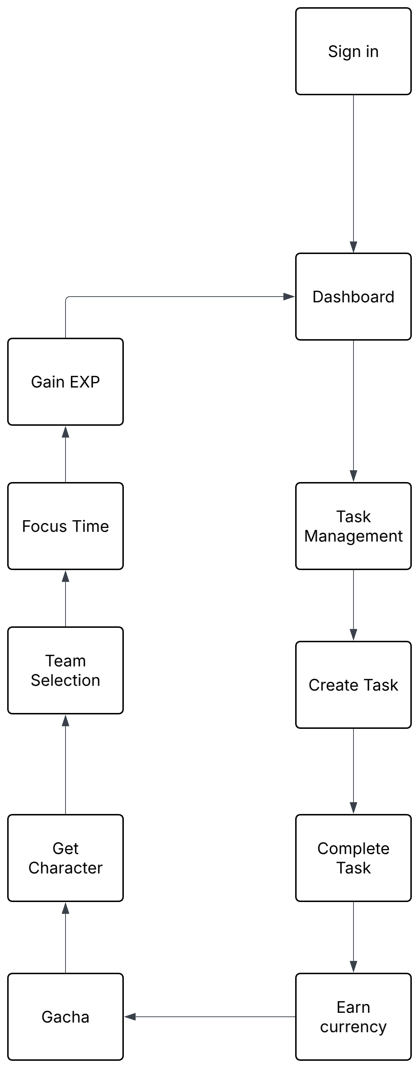
Figure 1: Flow chart of Adaptive Gamified Productivity System

User Interface Design
The interface was designed with simplicity as the primary goal. Given that the target users are people trying to be more productive, an overly complex or cluttered interface would likely undermine the purpose of the application. The system is made up of five main screens. The Dashboard gives users an overview of their stats and shortcuts to different screens. The Task Manager is where users create, edit and complete their tasks. The Gacha Screen is where users spend their currency and receive randomised characters. The Team Screen is where users pick up to three characters for battle mode. The Focus Screen is where the Pomodoro timer runs alongside the battle mechanic. The design prioritises clarity and accessibility to ensure users can easily interact with the system without confusion.
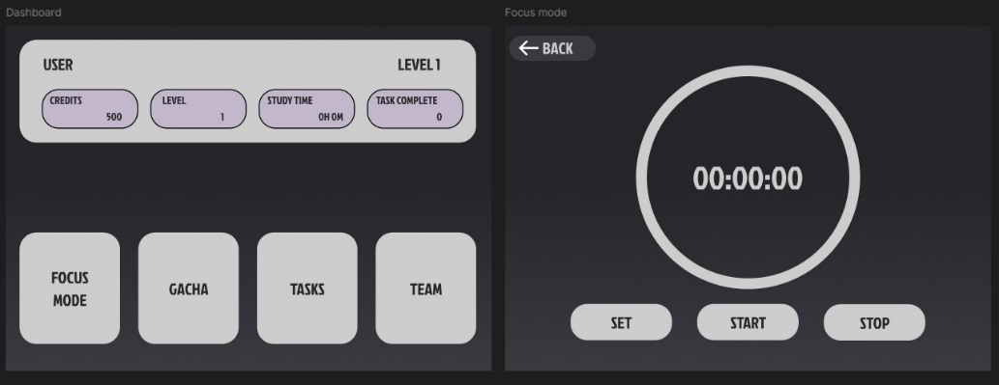
Figure 2: Figma wireframe for Dashboard and Focus Mode

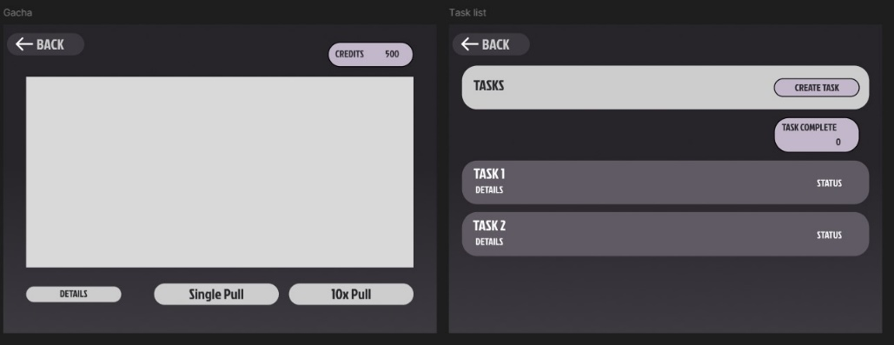
Figure 3: Figma wireframe for Gacha Interface and Task Manager

Figure 4: Figma wireframe for Team selection

Unique Selling Points
Unlike existing productivity apps such as Forest or Focus Plant which rely on visual progress as their main motivator, this system offers a more dynamic and engaging experience by combining task management with a gacha reward system. Users earn currency through completing real tasks, which they can then spend on randomised character rewards. This creates a sense of anticipation that simple progress bars or growing trees cannot replicate. While apps like Forest and Focus Plant tend to target users who prefer a simple and visually calming experience, this system is aimed at users who enjoy RPG-style progression and game-like rewards as a source of motivation. Additionally, all rewards are non-monetary and earned purely through productive activity, making it more ethical approach compared to other gacha systems found in typical games.

Technical Specifications

Tools and Platforms
- Engine: Unity
- Programming Language: C#
- Platform Target: PC
- UI and Graphics: Figma and Clip Studio Paint
Figma was used to design and plan the user interface layout before implementation. Clip Studio Paint was used to create original artwork and images used within the app such as character designs and UI elements

Constraints
- As the project was developed in Unity, it is currently limited to a standalone desktop build rather than cross-platform web application.
- The system does not currently use a backend database, meaning user accounts and data such as task and currency are stored locally.
- Network features such as user accounts or cloud saving were outside the scope of this project
- Development time and solo work limited the amount of content that could be produced, such as the number of available characters and other features

Risks and Challenges
There are risks associated with gacha mechanics as they have been known to negatively impact players. User might find the gacha system addictive in an unhealthy way, as there are cases where players spend large amounts of money trying to obtain their favourite characters or equipment in games like Genshin Impact (Lakić, 2023). To address this, all the rewards in this system are non-monetary and earned purely through completing tasks at a reasonable rate, avoiding any encouragement of compulsive behaviour. The system is designed so that users can still use the app effectively without obsessing over the gacha system. Additionally, there will be no time-limited characters or items as the limited availability is a common tactic that pressures players into excessive spending or grinding.
The randomness of rewards might feel unfair to some users. If rewards are too easy to obtain, they lose their meaning but if they are too difficult, users may lose motivation. A good example of this contrast is Fate/Grand Order and Genshin Impact, Fate/Grand Order has a very steep currency and reward rate that makes it extremely difficult for players to obtain what they want, whereas Genshin Impact provides more moderate reward rate that feels achievable (Thavamuni, 2023). This system takes a similar approach to Genshin Impact by setting currency rewards at a rate that encourages consistent use without making gacha pulls feel impossible to achieve.
Finally, new users who are unfamiliar with RPG elements might find the system confusing at first. To reduce this, the interface is kept simple and the core features such as the task manager and Pomodoro timer can be used independently without needing to fully understand the gacha or battle system straight away.

Conclusion

Justification
Existing applications demonstrate the effectiveness of gamification in productivity contexts. For instance, Forest encourages focus through visual growth-based rewards while games such as Genshin Impact maintain engagement through randomised gacha mechanics. However, these systems operate independently, with productivity applications typically lacking dynamic reward variability and games prioritising entertainment over functional productivity.
This project integrates these approaches by combining structured focus techniques with a randomised reward system, creating a hybrid model that enhances engagement while maintaining practical usability. By adapting these mechanics within ethical, non-monetised environment, the system aims to improve long-term motivation without encouraging excessive or compulsive behaviour.

Future Considerations
While the current version of the system covers the core features, there are several areas that could be expanded in future development. One planned addition is a wider variety of characters, each with their own backstory and context to make the experience feel more immersive and simulation-like for user. This would give users more reason to engage with the gacha system beyond just collecting characters for battle.
The Pomodoro focus screen could also be improved with simple idle battle animations, making the focus session feel more alive and visually engaging rather than just a static timer. This would strengthen the connection between productivity and the game-like experience the system aims to provide.
Finally, more customisation options could be introduced to allow users to personalise their experience, such as adjusting timer interavals, currency settings or visual preferences. This would make the system more flexible and better suited to different types of users and working styles.

Summary
This chapter has presented the Adaptive Gamified Productivity System, a productivity app that combines task management, gacha rewards and Pomodoro focus sessions to help users stay motivated and build consistent work habits. By linking productive behaviour directly to a reward system, the system aims to make the productivity feel more engaging than traditional tools. With planned improvements such as expanded character content, battle animations and greater customisation, the system has the potential to grow into a more complete and immersive experience.

IMPLEMENTATION or INVESTIGATION

Introduction
This chapter describes how the Adaptive Gamified Productivity System was built, covering the tools used, how the system was developed and the key features that were implemented. The goal was to take the design proposed in Chapter 3 and turn it into a working prototype that combines task management, focus sessions and a gacha reward system. Development followed an iterative approach, meaning features were built and tested gradually rather than all at once. This allowed problems to be caught early and improvements to be made throughout the process.

Development Environment
The system was built using three main tools. Unity was used as the primary development platform because of its flexibility in building interactive applications and its strong support for UI and event-driven programming. All system logic was written in C#. Figma was used before development began to design wireframes and plan the layout of each screen, which helped visualise how the system would look and feel before any code was written. Clip Studio Paint was used to create the character graphics and visual assets used throughout the app. These tools were chosen to support a modular and efficient development process.

System Architecture
The system was built using a modular structure where each component handles its own specific job while still connecting to the others. The main components are the Task Management System which handles task creation and completion, the Focus Timer System which manages Pomodoro sessions, the Gacha Reward System which generates randomised rewards, the Character Collection System which stores and displays collected characters and the User Interface Layer which connects the user to everything else. The key link between these components is that completing a task or focus session triggers the reward system, which then generates a random reward and updates the user’s collection. This creates a loop where productive behaviour is directly rewarded.

Feature Implementation

Task Management System
The task management system allows users to create, manage and complete tasks. A central service called TaskService handles all task data including creation, deletion and tracking completion status. Each task is stored as an object containing a title and completion state, which is then displayed through the interface so users can interact with it easily. When a user marks a task as complete, the system triggers a currency reward and updates the task status accordingly. A saving mechanism was also implemented using local file storage to ensure tasks are retained between sessions so users do not lose their progress when they close the app.

Pomodoro Timer System
The focus timer is based on the Pomodoro Technique and was implemented through a module called PomodoroTimer. Users can start a structured work session and the timer counts down in real time updating the circular timer UI every second to show how much time is remaining. Once the session reaches zero, the system automatically ends the session notifying the users and triggers the experience point reward module. This direct link between completing a focus session and receiving a reward was an intentional design decision to ensure that the Pomodoro system felt meaningful rather than just a standalone timer.

Gacha Reward System
The gacha system is one of the most important parts of the project. A service called GachaService selects rewards from a predefined pool based on probability and rarity, using a random selection algorithm to keep outcomes unpredictable. Rewards are only granted after the users complete a task and earn the currency ensuring that the system reinforces productive behaviour rather than rewarding repeated interaction with the gacha screen directly.

Character Collection System
Once rewards are earned, they are stored and managed through the character collection system. Classes such as CharacterInventory and CharacterCollection handle collected items and allow users to view what they have obtained. This gives users a sense of progression and achievement which helps motivate them to keep using the app.

Gamification and Progression System
Additional gamification features were implemented to make the experience feel more game-like. These include team building and battle-related elements where users can select up to three characters to form a team that participates in focus session battles. During a Pomodoro session, the selected characters engage in a simplified battle against enemies and completing the session rewards the user with EXP allowing them to level up over time. While these features are simplified in the current version, they add an extra layer of interaction that makes productivity feel more engaging than a standard timer or to-do list.

User Interface Implementation
The user interface was built inside Unity with simplicity as the main priority. The main screens include the Dashboard which shows stats and shortcuts to other screens, the Task Manager where users can create and complete tasks, the Gacha Interface where rewards are displayed after a pull and the Focus Mode screen where the Pomodoro timer runs. All UI elements were designed to be easy to navigate and provide real time feedback so users always know what is happening in the system.

Development Process
Development was done in stages, starting with the core features first. The task management system and Pomodoro timer were built and tested before anything else, as these form the foundation of the app. Once those were working, the gacha reward system and character collection features were added on top. Gamification elements such as the team and battle system were implemented last. Testing was done throughout each stage to make sure everything worked properly before moving on to the next feature.

Project Planning
Development was planned to use a Gantt chart which divided the project into phases including design, development, testing and evaluation. While the overall structure was followed, some adjustments were made along the way to deal with technical challenges and improvements that came up during development. This flexible approach helped keep the project on track without being too rigid
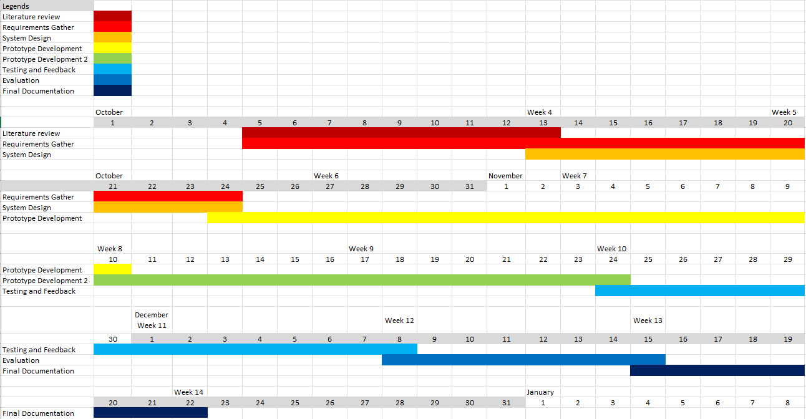
Figure 5: Gantt Chart

Challenges and solutions
Several challenges came up during development. The first was integrating multiple systems, making the task system, timer and reward system all communicate with each other correctly, took careful planning. This was solved by keeping each component modular and defining clear points where they interact with each other.
Balancing the reward system was another challenge as getting the probability and rarity distribution to feel fair without being too easy or too difficult required a lot of testing and adjusting to get right.
The user interface also went through changes throughout development. Early design felt too empty and were not usable enough, so they had to be polished and improved. For example, the Focus Timer screen originally displayed a flat time bar which was later replaced with a circular timer UI with a countdown in the middle, making it feel cleaner and easier to read. The Gacha screen also went through changes, the original character designs were replaced with more polished artwork and banner system was added so that users could clearly tell when they received a duplicate character, rather than thinking the screen had glitched when pulling twice.
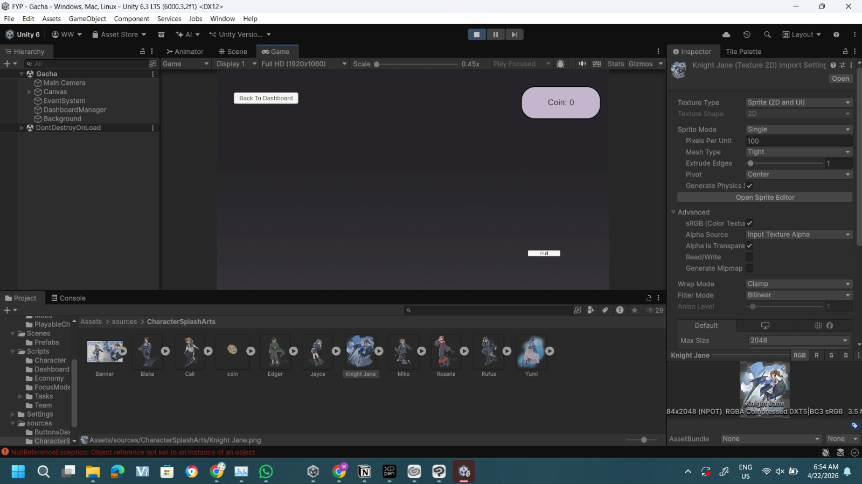
Figure 6: Gacha Screen Before Changes
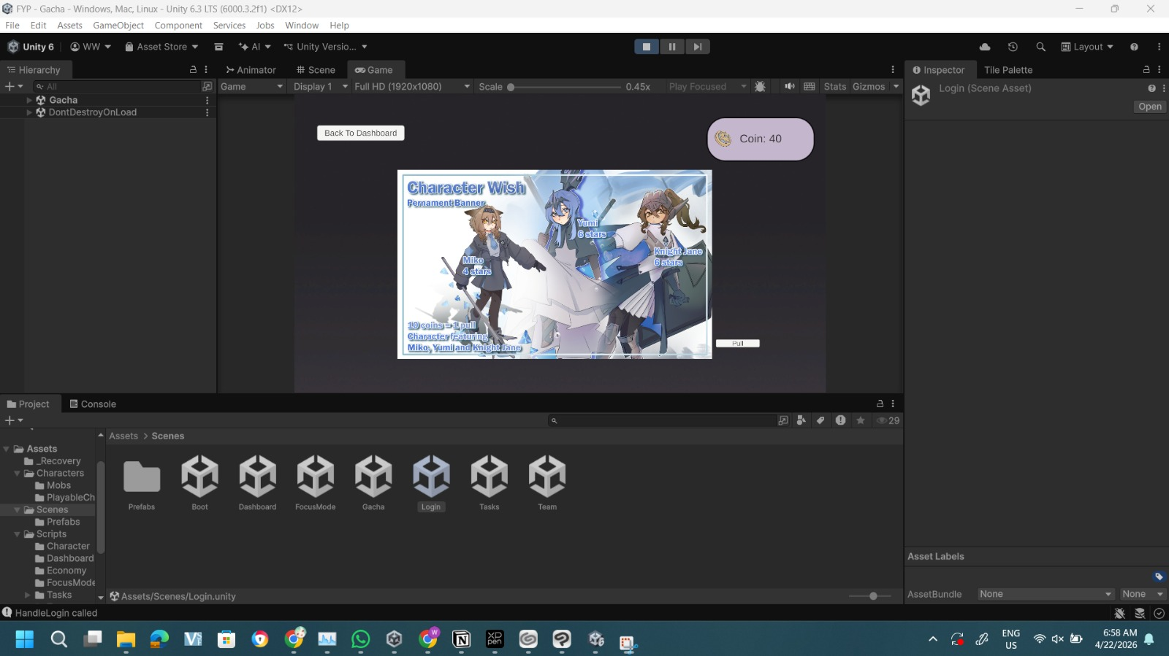
Figure 7: Gacha Screen After Changes
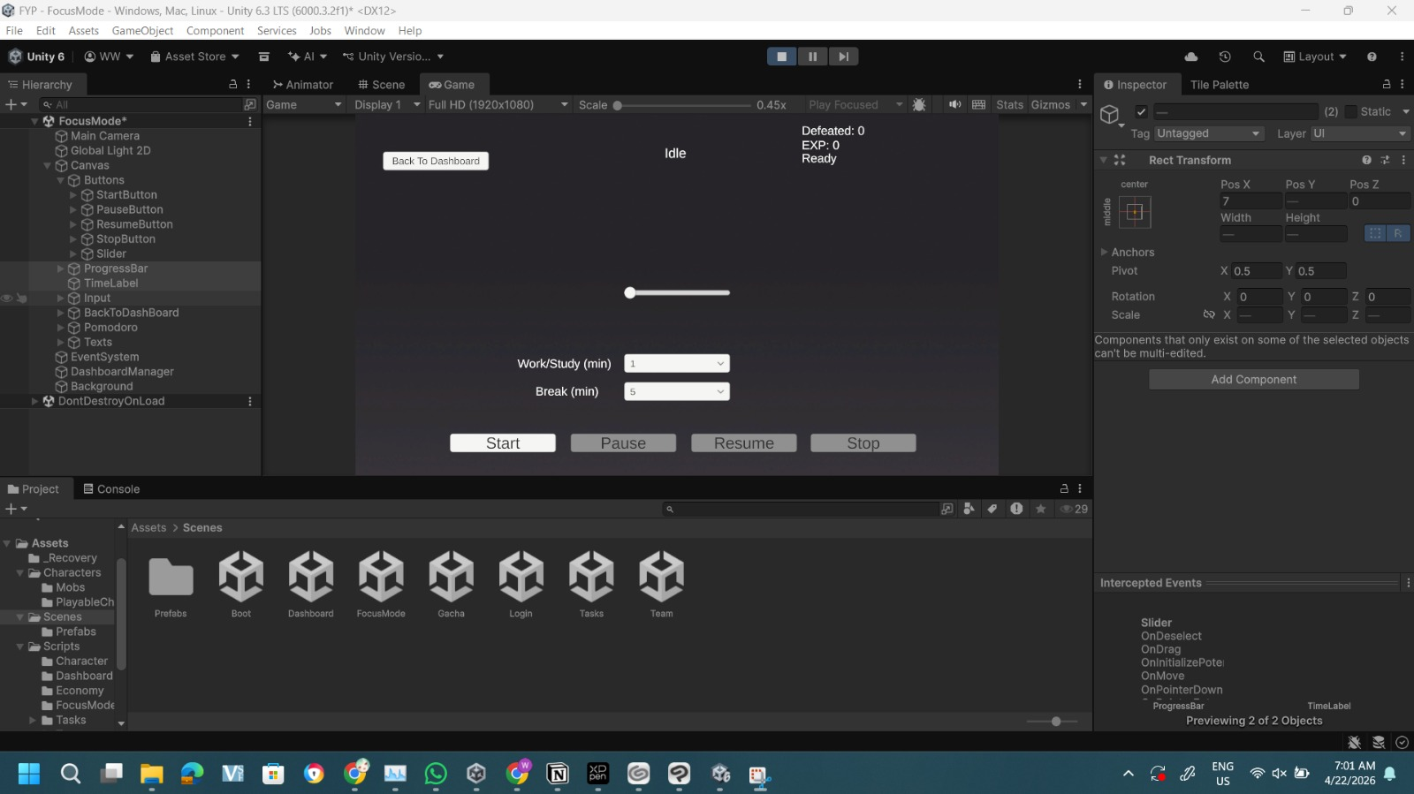
Figure 8: Focus Timer Screen Before Changes
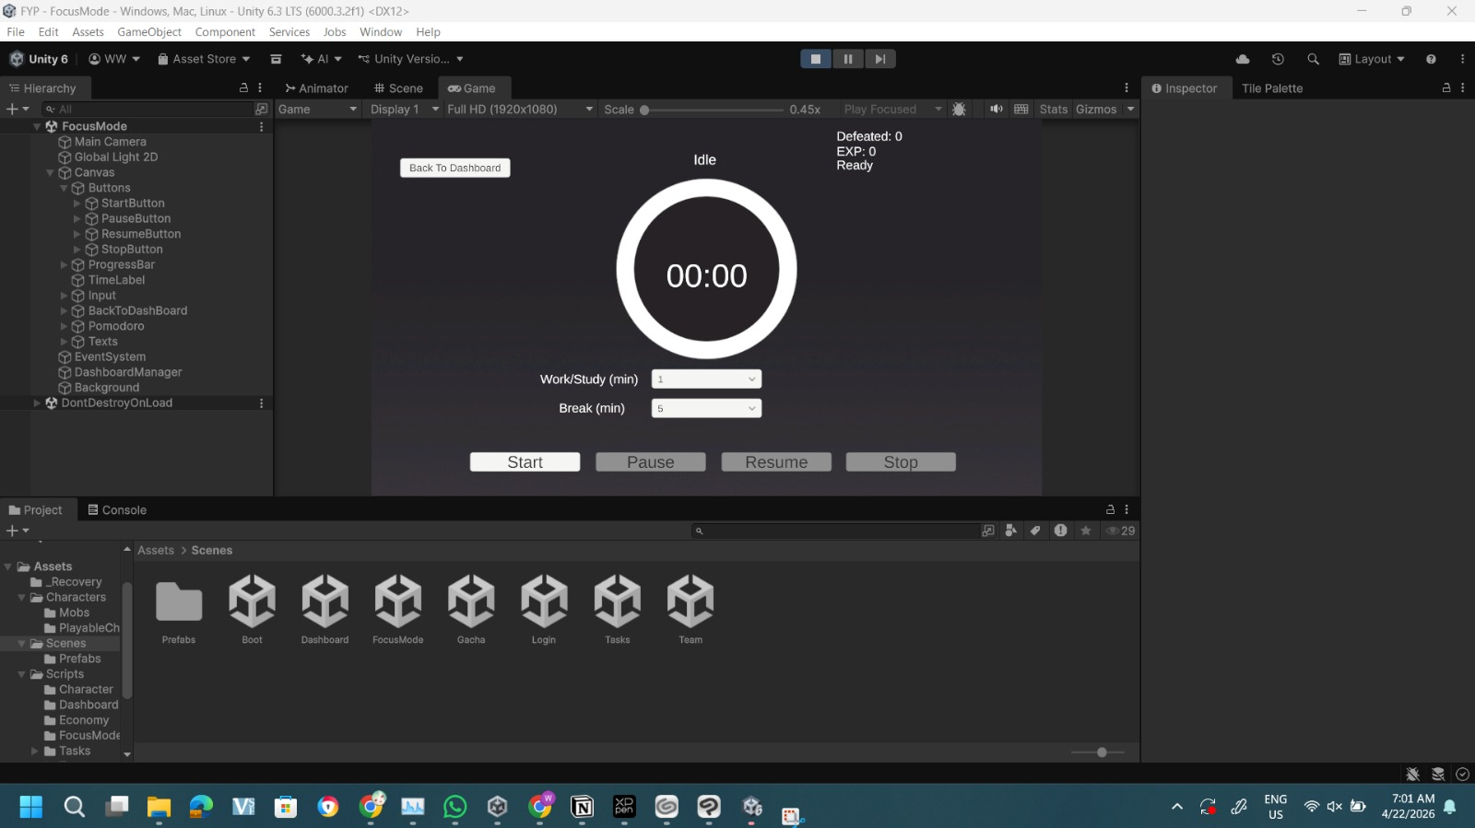
Figure 9: Focus Timer Screen After Changes

Finally, getting data to save and load correctly between sessions required debugging the save system until it worked consistently.

Summary
This chapter has covered how the Adaptive Gamified Productivity System was built, from the tools and architecture to the individual features and challenges faced along the way. The final prototype successfully brings together task management, Pomodoro focus sessions and a gacha reward system into one working application.

RESULTS / DISCUSSION

Introduction
This chapter presents the results of the user evaluation conducted on the Adaptive Gamified Productivity System prototype. The purpose of this evaluation is to assess the system in terms of usability, engagement, motivation and overall effectiveness.
The evaluation was carried out using a structured survey complete by participants after using the system. The results are analysed and discussed in relation to the project objectives stated in Chapter 1 and the design decisions explained in Chapter 3 and Chapter 4.
The user testing consisted of 7 participants who were known to the researcher. This may introduce some bias as participants might provide more positive feedback. However, the results still provide useful initial insights into how the system performs.

Functional Testing
Functional testing was carried out using a black box testing approach where each core feature was tested based on expected inputs and outputs. The following test cases cover the main features of the system.
Test Case ID | Test Scenario | Input | Expected Result | Actual Result | Pass/Fail
FT01 | Navigate between screens | Tap Task, Gacha, Team, Focus screens and go back to Dashboard Button | Each screen loads correctly without crashing | Each screen loads correctly without crashing | Pass
FT02 | Create a new task | Enter task name and confirm | Task appears in the task list | Task appears in the task list | Pass
FT03 | Complete a task | Mark task as complete | Task marked done, currency awarded | Task marked done and strike off, currency awarded | Pass
FT04 | Delete a task | Select delete on existing task | Task removed from list | Task deleted from the task list | Pass
FT05 | Edit a task | Select edit on existing task | Task can be edited | Did not implement | Fail
FT06 | Start Pomodoro Timer | Press start on focus screen | Timer counts down | Timer counts down | Pass
FT07 | Complete Pomodoro session | Allow timer to reach zero | Session ends, EXP is earned | Session ends, EXP is earned | Pass
FT08 | Pause Pomodoro session | Press pause on focus screen | Timer pause without resetting | Timer pause without resetting | Pass
FT09 | Stop Pomodoro session | Press stop on focus screen | Timer resets | Timer resets | Pass
FT10 | Resume Pomodoro session | Press resume on focus screen | Timer continues from paused timer | Timer continues from paused time | Pass
FT11 | Perform gacha pull | Spend currency on gacha screen | Random character received | Random character received | Pass
FT12 | Insufficient currency pull | Attempt to pull without currency | No pull, error shown | No pull but no error shown | Partially pass
FT13 | Add character to team | Select character for team slot | Character added to team of three | Character added to team of three | Pass
FT14 | Remove character from team | Select remove button below the team slot | Character gets removed from the slot | Character gets removed from the slot | Pass
FT15 | View character collection | View the character collection next to the team slot | All owned characters displayed | All owned characters displayed | Pass
FT16 | Save and reload data | Close and reopen app | Tasks and currency retained | Tasks and currency retained | Pass
FT17 | Currency updates live after task completion | Complete task | Coin balance increases immediately on screen | Coin balance increases immediately | Pass
FT18 | Currency balance consistent across screens | Earn coins on task screen, switch to dashboard and gacha screen | Same balance shown on dashboard and gacha screen | Same balance shown on dashboard and gacha screen | Pass
FT19 | Stats save after closing app | Earn coins and characters, close and reopen app | Coins and collection retained | Coins and collection retained | Pass
FT20 | Character collection updates after pull | Perform gacha pull | New character appears in collection immediately | New character appears in collection immediately | Pass
FT21 | EXP earned after Pomodoro session completes | Complete at least 1 minute for 10 EXP | Earn 10EXP | Earn 10EXP after completing 1 minute | Pass
FT22 | EXP convert into one level | Collect at least 300 EXP from Pomodoro sessions | Accumulate 300 EXP and convert to 1 level and reset the EXP for the next level | Accumulate 300 EXP and convert to 1 level and reset the EXP for the next level | Pass
Table 1: Black box testing

Non-Functional Testing

Methodology
The evaluation was conducted using a mixed method survey combining quantitative rating scale questions and qualitative open-ended responses. Participants were asked to use the prototype for a few days and then complete a Google Form survey consisting of demographic questions, pre-use background questions and post-use rating and feedback questions. All responses were anonymous and participants provided informed consent before taking part.
A total of 7 participants took part in the evaluation. While the original target was 10 participants minimum as stated in the project objectives, there are findings from 7 participants which still provide useful initial insights into the usability and engagement of the system. Bigger sample would needed to have broader conclusions and more extensive evaluation is recommended as a direction for future work.

Participants Demographics
Out of 7 participants, the majority fell within age range 18 to 24 with 5 participants, one participants aged under 18 and one aged between 25 and 34. In terms of occupation, 6 participants were students and 1 was in employment. The demographic is broadly aligned with the target user for the system as students represent a group that regularly engages with tasks, deadlines and the need for focus management.
When asked about prior experience with productivity tools, 3 participants had used productivity apps such as Notion, Forest or Flow before while the other 4 had not. This shows a mix of users who could make comparisons with existing tools and those who approach the system without prior expectations. 6 out of 7 participants have experience with gacha or random reward systems through games. This is relevant as familiarity with gacha mechanics may have influenced how participants responded to the reward system.
Participants were also asked to rate how much they struggle with staying focused on a scale of 1 to 5. Scores ranged from 2 to 5 with most participants rating a 4 indicating that the majority of participants have experience some difficulty with focus that aligns with the problem the system is designed to address.

Usability Results
Usability was assessed through two rating questions asking participants to rate how easy the system was to use and how clear the interface was both on a scale of 1 to 5.
The system received an average usability rating of 4 out of 5 with scores ranging from 3 to 5. Three participants rate usability at 3 which shows that there is room for improvement in making certain features more immediately intuitive. The interface clarity received a slightly higher average of 4.43 out of 5, with the majority of participants rating it 4 or 5. This suggests that the visual design and layout were generally well received and easy to understand.
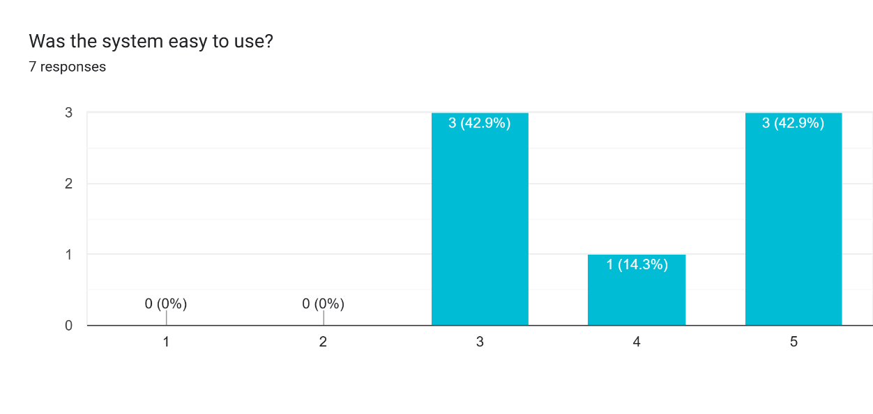
Figure 10: Usability rating

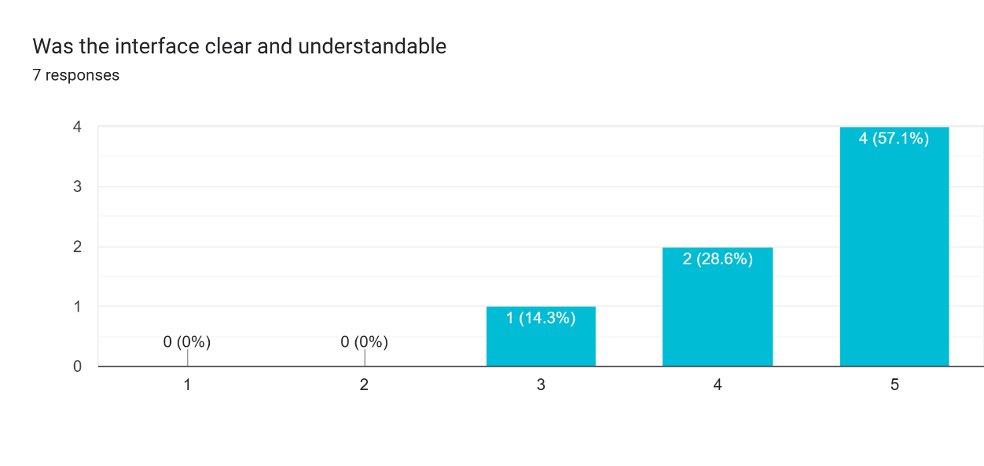
Figure 11: Interface clarity rating

Engagement and Motivation Results
Several questions focused on whether the system improved engagement and motivation after the usage for a week. These results are central to the core objective of the project.
The reward system received an average engagement rating of 4.29 out of 5 when participants were asked if it made tasks more engaging. One participant rated this a 2 stating that they did not personally connect with the randomised reward concept. The participant commented that it was not for them as someone who does not engage with games. All other participants who engage with game rated it 4 or 5 which suggests that the reward system was effective for its intended audience.
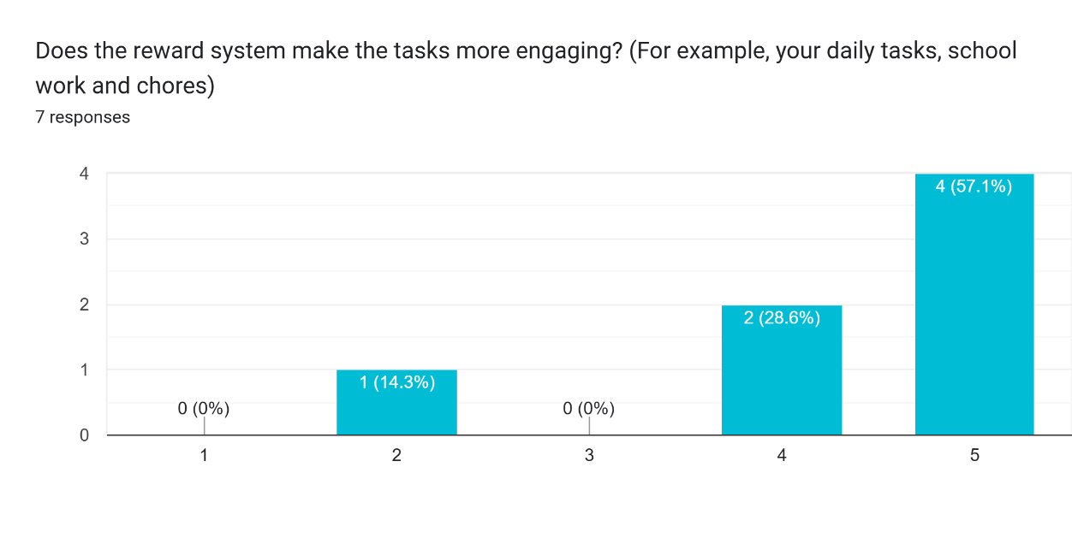
Figure 12: Engagement rating
Motivation was rated at an average of 4 out of 5 with participants generally reporting that the prototype made them feel more motivated to complete tasks. Participants rated the enjoyability of random rewards at 4.14 out of 5 and the ability of the reward system to encourage continued use at 4.14 out of 5. These consistent scores across engagement related questions indicating that the gacha reward system was successful in providing motivational reinforcement for the majority of participants.
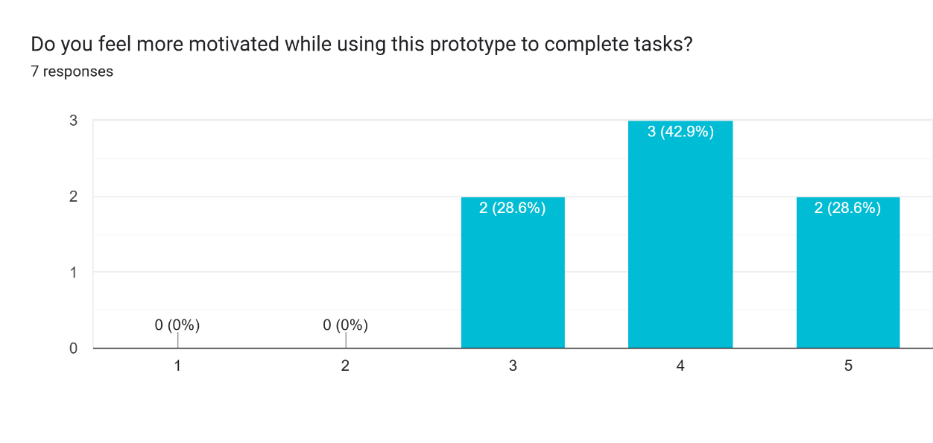
Figure 13: Motivation rating

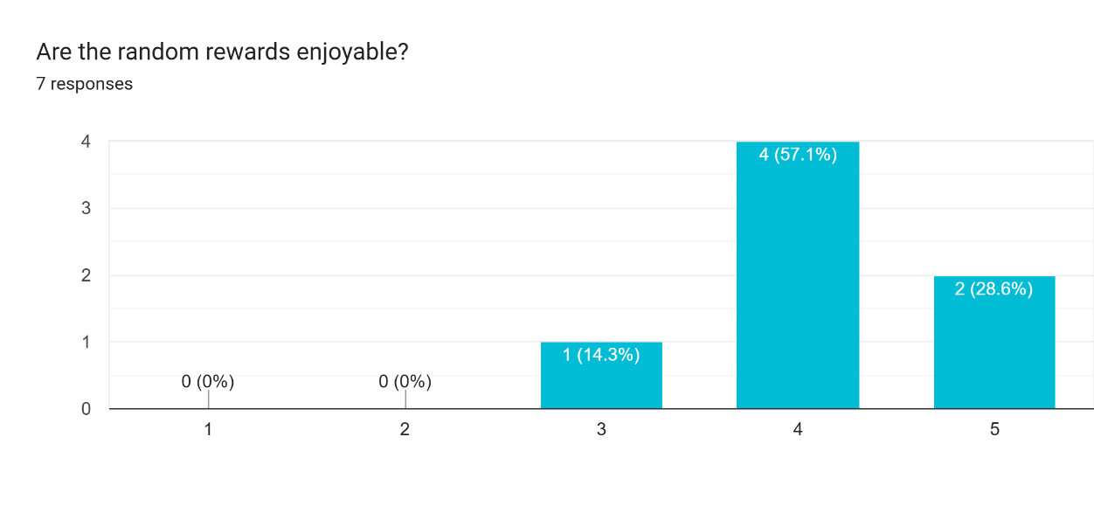
Figure 14: Enjoyability rating of random rewards
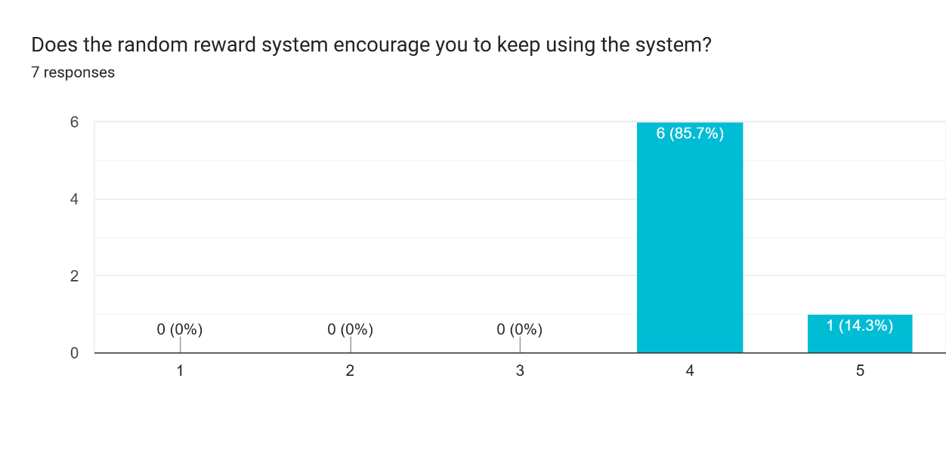
Figure 15: Continue usage of the system rating
When asked what they liked the most about the system, responses highlighted that reward and progression elements as key strengths. One participant noted “I like the characters and having my own personal levelling up like RPG game” while another said that they liked “the concept of combining game and productivity together." These response explained that RPG-style progression and collection mechanics resonated positively with users, especially those already familiar with gacha games.

Focus and Productivity Results
Participants were asked if the system helped them stay focused and whether it improved their general experience of completing tasks. Focus received the lowest average rating of 3.71 out of 5 with three participants rating it 3. While the system is meant for focus, it was the weakest performing area of the evaluation. This is expected given that the battle mechanic during focus sessions was in a simplified state in the current prototype and a more visually engaging focus screen with animations as discussed in the section 3.10.2 Future Consideration may improve this result.
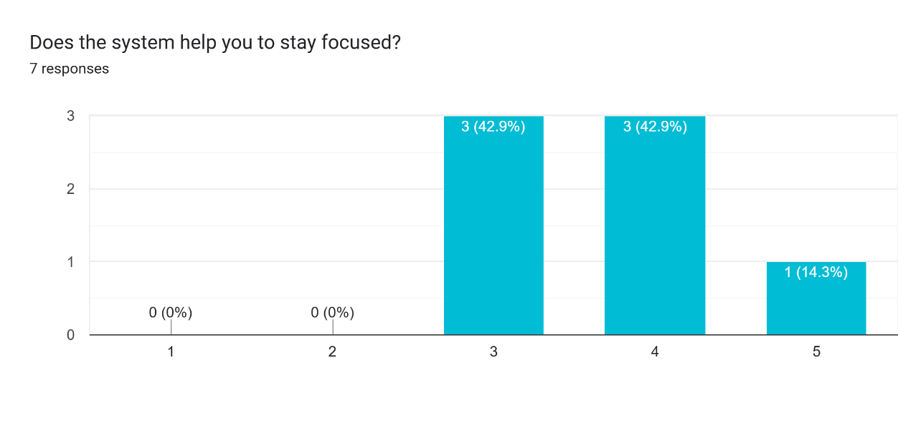 Figure 16: Focus rating
Overall improvement to productivity experience was rated at 4.14 out of 5. When the participants were asked if they would prefer this system over other productivity tools they had used, participants rated an average of 4.14 out of 5. These results showed that participants found the system to be a improvement over standard productivity tools.
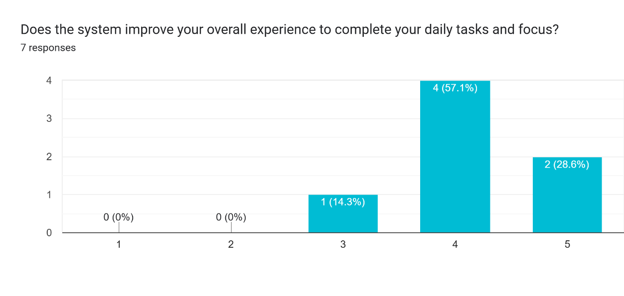 Figure 17: Improvement rating
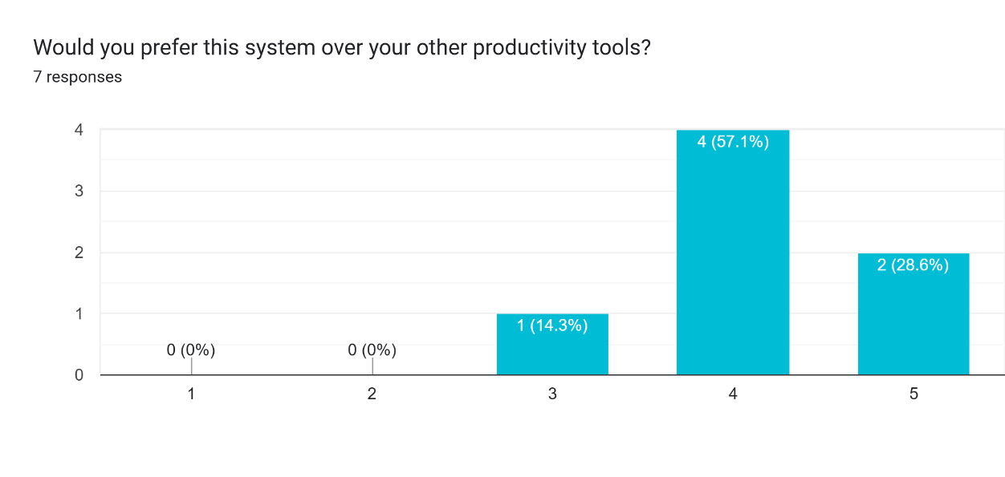 Figure 18: Productivity over other tools rating

Ethical Design Results
Given the ethical concerns around gacha mechanics discussed in Chapter 2, participants were asked whether they felt the system was fair and not addictive. This received an average of 4.29 out of 5, with no participant rating it below 4. This implies that the ethical design decisions made during development were effective in making the system feel responsible rather than exploitative with removing time-limited items, keeping the rewards non-monetary and trying pulls to productive behaviour.
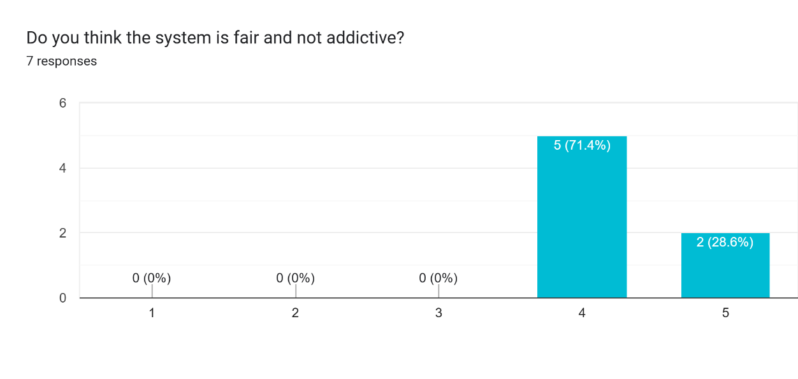 Figure 19: Reward fairness and addictive rating

Quantitative Results
Participants were asked to rate the system across eleven criteria using scale of 1 to 5 where 1 represents strong disagree and 5 represents strongly agree. The table below summarises the average score for each question for all 7 participants.
Metric | Results (average out of 5) | Notes
Easy to use | 4 | Met expectations
Interface clarity | 4.43 | Met expectations
Reward engagement | 4.29 | Met expectations
Feel motivated | 4 | Met expectations
Would use again | 4 | Met expectations
Rewards enjoyable | 4.14 | Met expectations
Rewards encourage continued use | 4.14 | Met expectations
Fair and not addictive | 4.29 | Met expectations
Help focus | 3.71 | Slightly below expectations
Improves overall experience | 4.14 | Met expectations
Prefer over other tools | 4.14 | Met expectations
Table 2: Black box testing
The results show that the system performed consistently well across categories with the majority of scores falling at or above 4 out of 5. The highest rated areas were interface clarity at 4.43 and reward engagement at 4.29 while focus support received the lowest average of 3.71. These findings are discussed further in the Section 5.3 Non-Functional Testing.

Qualitative Feedback
Open ended response provided additional insight into user experience beyond the numerical ratings. The most commonly mentioned positives were the reward system, the user friendly interface and RPG-like progression. Improvements focused primarily on customisation and visual variety with multiple participants requesting more themes, background options and the ability to customisable features. One participants specifically requested animations and ranking system to make the experience more dynamic.
One participant from the 25 to 34 age group who did not play gacha games provided a notably different perspective, rating several features lower and commenting that the randomised reward concept was not personally appealing. This shows important consideration that the system is most effective for users who are already familiar with and enjoy gacha mechanics in games. For users outside this demographic may feel less relevant is worth acknowledgment as a limitation.
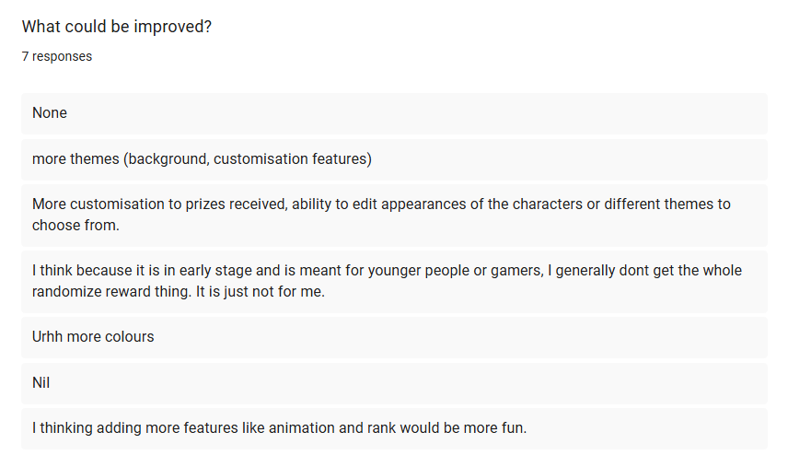 Figure 20: Improvement Feedbacks

Successes and Limitations
The system was successful in several key areas. Usability and interface clarity received strong ratings of 4 and 4.43 out of 5 respectively shows that the design decisions made during development resulted in an interface that users found accessible and easy to navigate. The gacha reward system was also a clear strength with reward engagement scoring 4.29 out of 5 and the fairness of the reward system scoring 4.29 out of 5. The ethical design decisions such as removing time-limited items and keeping rewards non-monetary were effective in making the gacha feel rewarding without feeling exploitative. The RPG style progression and collection mechanics were also well received with participants enjoying these features.
However, there are several limitations to acknowledge. The focus feature received the lowest average rating of 3.71 out of 5 indicating that the Pomodoro battle mechanic in its current simplified form did not full deliver the intended game-like experience during focus sessions. The absence of animations and interactive feedback during the focus likely contributed to this lower score. Another limitation is the participant sample which was consisted of 7 users who were known to the researcher. This means the results reflect a narrow demographic and may not represent how the system would perform with a more diverse audience. The response from one participant who did not play games and rated several features lower highlights that the system in its current form is the most effective for users who enjoy gacha game mechanics before which is an important consideration for future development.

Discussion
Overall, the result indicates that the system has achieved its main goal of improving engagement and motivation in productivity tasks.
The strong engagement results can be explained by the use of randomised rewards. As discussed in Chapter 2, unpredictable rewards are more effective at keeping users interested compared to fixed rewards. This supports the idea that the gacha system plays a key role in maintaining user engagement.
The results also show that users who are familiar with games responded more positively to the system. The design is well suited for a specific group of users who enjoy RPG-style progression and collection mechanics.
However, the lower focus score indicates that engagement alone does not guarantee improved concentration. The current focus system lacks visual and interactive elements which reduce its effectiveness. This shows that further development is needed to support focus better.
The feedback also highlights the importance of balancing intrinsic and extrinsic motivation. While rewards can encourage users to complete tasks, long-term use may depend on whether the system becomes genuinely useful and enjoyable beyond just rewards.
Finally, the small sample size and limited diversity of participants mean that the results cannot be generalised. A larger and more varied group would provide clearer understanding of how effective the system is in different contexts.

Summary
This chapter has presented the results of the user evaluation, covering usability, engagement, motivation, focus and ethical design.
The findings show that the system was well received particularly for its reward system and game-like progression. These features helped improve motivation and overall user experience.
However, the result also highlight areas for improvement especially in focus support and customisation.
The system demonstrates strong potential as a gamified productivity tool, with further improvements needed to enhance its effectiveness and broaden its appeal.

CONCLUSIONS / FUTURE WORK

Conclusions
This project aimed to design and develop an Adaptive Gamified Productivity System that improves user motivation through reward-based mechanisms. The system combined task management, a Pomodoro focus timer and a gacha-style reward system into a single application.
Overall, the project was successful completed. A working prototype was developed with Unity and most main features were implemented including task creation, focus sessions, random reward and character collection. The system was tested through user evaluation and the results showed that it was generally well received.
The findings from Chapter 5 indicate that the system was effective in improving user engagement and motivation. The random reward system played a key role in making tasks more interesting and encouraging continued use. Most participants found the system easy to use and preferred it over traditional productivity tools.
However, the results also showed that the system was less effective in improving focus compared to engagement. While gamification can increase motivation, additional improvements are needed to support focus better during tasks.
The project is met with objective of demonstrating how gamification and reward systems can be applied to productivity tools to enhance user experience.

Review of Objectives
The objectives outlined in Chapter 1 were mostly achieved. The system successfully provided a task management interface where users could create, edit and complete tasks. A Pomodoro-based focus timer was implemented to structure work sessions and users were rewarded after completing tasks and focus sessions.
A gacha reward system was also successfully integrated allowing users to receive randomised characters. These characters were then used within the system to create a sense of progression through experience points and levelling.
User evaluation was conducted to assess the effectiveness of the system. The results showed that the system improved engagement and motivation for most users.
Finally, a functional prototype was produced, demonstrating the concept and showing how different components work together.
While all main objectives were achieved, some features such as task editing and more advanced focus mechanics were fully developed which leaves room for further improvement.

Limitations
There are several limitations to this project.
One of the main limitations is the small sample size used during evaluation. Only 7 participants took part in the testing which limits how reliable the results are. A larger and more diverse group would provide more accurate results.
Another limitation is that the system was developed as standalone desktop application without a backend database. This means that data is stored locally and cannot be accessed across different devices.
The system is also limited in terms of content. The number of characters and features is relatively small due to time constraints and the project being developed by a single person. In addition, the focus system is still basic. The battle mechanic during Pomodoro lacks interaction and visual feedback which may reduce its effectiveness in helping users.
Finally, the system may not appeal to all users. The results showed that users who are not familiar with gacha games may not find the reward system engaging. This means the system is more suitable for a specific target audience rather than general users.

Future work
There are several areas where the system can be improved in future development.
One possible improvement is to expand the character system. More characaters can be added with different designs, abilities or background stories to connect with players to make the system more engaging. Characters also can have levelling up system using the levelling up materials by defeating mobs from the Pomodoro session. Duplicate characters could also be used to rank up existing characters, giving the users more reasons to continue collecting.
The focus system can also be improved by adding animations, visual effects or simple interactions during the Pomodoro session rather than just a timer to make the experience more engaging and help improve focus.
Most customization options could be introduced such as allowing users to adjust their settings, change themes or personalise their interface. This would make the system more flexible and suitable for different users.
Another improvement is to add a backend system with cloud saving. This would allow users to access their data across multiple devices and improve overall usability.
A mobile version of the application could also be developed as mobile platforms are more commonly used for productivity apps. This would make the system more accessible and convenient for users.
Finally, a larger-scale user evaluation should be conducted with more participants from different backgrounds. This would provide more reliable results and a better understanding of how effective the system is in real-world use.

Legal, Social, Ethical and Professional Issues (LSEPI)
The use of gacha mechanics raises ethical concerns as these systems are often associated with gambling-like behaviour. In this project, all the rewards are non-monetary and earned only through completing productive tasks or focus sessions. There are no time-limited items or real money transactions which removes the most two commonly causes of compulsive spending in commercial gacha games. The system was designed in line with the ethical principles discussed in Chapter 2 ensuring that the reward mechanics encourage motivation rather than compulsive behavior. This was supported by the evaluation results where participants rated the system 4.29 out of 5 in fairness and non-addictive.
Data privacy is another important consideration. Since the system stores user data locally rather than on a remote server, there is minimal risk of data being accessed by third parties. No personal information is collected by the application itself. During user testing, all the participants provided informed consent before taking part and were made aware that their responses would be used only for academic purposes. No sensitive personal data was collected. These practices align with the principles of GDPR as outlines in the project proposal document.
From a social perspective, the system was designed with accessibility and simplicity in mind to ensure it could be used by a broad range of users. While the current version targets users who are comfortable with gacha mechanics, future development would aim to make the system more inclusive for users who are less familiar with RPG or gacha systems widening its social impact.

Synoptic Reflections
This project provided valuable experience across both technical development and the wider process of designing, testing and evaluating a software system from concept to working prototype.
From a technical perspective, the project significantly improved skills in Unity development. Working with multiple interacting systems such as the task manager, timer, gacha service and character collection, required a clear understanding of how to structure code modularly so that each components can be built and tested independently. This was a challenge in early development but became more manageable in later development. The experience of debugging data persistence and integrating a weighted random algorithm for the gacha system also provided practical exposure to real development problems.
The project also strengthened design skills. Using Figma to plan wireframes before writing any code was a process that proved genuinely useful as it helped identify layout issues early and give a clear visual target to work towards during implementation. Creating original artwork in Clip Studio Paint for the character designs added a creative dimension to the project that made the final prototype feel more polished. This combination of technical and creative work reflects the kind of pipeline used in game and interactive media development which aligns closely with the career goals outlines at the start of the project.
Working on a solo project of this scale also developed project management and time management skills. Following the Gantt chart structure helped maintain a clear development roadmap through the experience of making adjustments when features took longer than expected highlighted the importance of building flexibility into any development plan. In hindsight, allocating more time to the focus session and character mechanics and user testing recruitment would have produced stronger results in both of those areas.
Finally, conducting user testing and analysing the results provided insight into user-centred design. Seeing how real users interacted with the system was a more grounding experience than developing in isolation. The feedback reinforced the value of testing early and iterating based on real responses rather than assumptions. This project has built a foundation of skills relevant to careers in game development, UX design and interactive system design. The prototype represents a meaningful addition to a portfolio.

ReferenceS
- Eren Ogut (2025). Assessing the efficacy of the Pomodoro technique in enhancing anatomy lesson retention during study sessions: a scoping review. BMC Medical Education [online].
doi:https://doi.org/10.1186/s12909-025-08001-0
- Eva, Wenzel N. and Bruin (2025). Investigating the Effectiveness of Self-Regulated, Pomodoro, and Flowtime Break-Taking Techniques Among Students. Behavioral Sciences [online]. doi:https://doi.org/10.3390/bs15070861
- Contretras Pinochet (2020). Intention to continue to use mobile productivity apps. [online]. doi:https://doi.org/10.12712/rpca.v14i2.40848
- Christopoulos and Mystakidis (2023). Gamification in Education. Encyclopedia [online]. doi:https://doi.org/10.3390/encyclopedia3040089
- Hellín C.J (2023). Enhancing Student Motivation and Engagement through a Gamified Learning Environment. Sustainability [online]. doi:https://doi.org/10.3390/su151914119
- Rahiman H.U. (2023). Game on: Can gamification enhance productivity? [online]. doi:https://doi.org/10.12688/f1000research.131579.2
- Thavamuni, S. (2025). Analyzing The Gacha System in Genshin Impact: Odds, Mechanics, And Player Enticement. Asia-Pacific Journal of Information Technology and Multimedia [online]. doi:https://doi.org/10.17576/apjitm-2025-1401-04
- Sagguneswaraan Thavamuni (2025). Inherent Addiction Mechanisms in Video Games’ Gacha. Information, [online]. doi:https://doi.org/10.3390/info16100890
- Ryan R.M. and Deci E.L. (2020). Intrinsic and Extrinsic Motivation from a self-determination Theory perspective: Definitions, theory, practices, and Future Directions. Contemporary Educational Psychology, [online]. doi:https://doi.org/10.1016/j.cedpsych.2020.101860
- Osmond Chia (2022). Dad saddled with $20, 000 credit card bill after daugther’s in-game spending spree on Genshin Impact | The Straits Times. [online]. Available at: https://www.straitstimes.com/singapore/community/dad-saddled-with-20000-credit-card-bill-after-daughters-in-game-purchase-spree-on-genshin-impact

Appendix A
A1 Survey Questions
The following questions were included in the post-use survey:
- Was the system easy to use? (1-5)
- Was the interface clear and understandable? (1-5)
- Does the reward system make the tasks more engaging? (For example, your daily tasks, schoolwork and chores) (1-5)
- Do you feel more motivated while using this prototype to complete tasks? (1-5)
- Would you use this system again? (1-5)
- Are the random rewards enjoyable? (1-5)
- Does the random reward system encourage you to keep using the system? (1-5)
- Do you think the system is fair and not addictive? (1-5)
- Does the system help you to stay focused? (1-5)
- Does the system improve your overall experience to complete your daily tasks and focus? (1-5)
- Would you prefer this system over your other productivity tools? (1-5)
- What do you like the most about the system? (open-ended)
- What could be improved? (open-ended)

A2 Additional Notes
All responses were collected anonymously using an Google survey form. The results were summarised and analysed in Chapter 5.
A3 System Usage
To use the system, the user starts by signing in and accessing the dashboard. Tasks can be created and completed through the task manager. Upon completing tasks, users earn currency which can be used in the gacha system to obtain characters. These characters can be selected into a team and used during focus sessions to gain experience points.

